Lebanese American University



Digital Systems Lab

Final Project

Anas Honeini: 202000103

Rami Hamadeh: 202000514

Anthony Tannous: 202004118

Richard Younes: 202004917

Luidovic Zgheib: 202001451

Submission date: Saturday, December 2, 2023

Contents

Introduction 3

Project Description 4

Assumptions 4

State Diagram 4

Exit FSM: 6

Normal FSM: 7

Administrator Mode: 8

Conclusion 10

Table of Figures

Figure 1 shows the main FSM of the state diagram. 4

Figure 2 shows the exit FSM in the state diagram. 6

Figure 3 shows the normal FSM in the state diagram. 7

Figure 4 shows the FSM of the administrator mode. 8

# Introduction

The Parking Management System described in this project represents an innovative solution for efficient and secure parking facilities. The system is intended to work in a two-level parking lot that has sensors to track vehicle occupancy. It makes use of a PS2 keyboard, an LCD, 7-segments, and LEDs. Ten parking spaces overall, two of which are set aside for those with special IDs. Each floor can hold up to five cars. Parking access extends to 14 additional IDs, making a total of 16 authorized users. Apart from those with special IDs, new entrances are prohibited, and the parking is filled up according to the "first come, first served" policy. There are eight non-reserved slots. The security guards stationed at the entrance and exit gates own admin IDs, which enable them to oversee gate functions like overrides and prevent unwanted entry. This report details the functional aspects, features, and implementation of the Parking Management System, offering insights into its practicality and effectiveness.

# Project Description

In this project, we are required to design a two-level parking lot. In each level, 5 vehicles are allowed to park. In the first one (Level 0), 2 spots are reserved for special IDs and 3 for normal IDs, as for the second floor (level 1) the 5 spots are reserved for the normal IDs. Additionally, an administrator mode is available for 2 IDs only. In this mode, the admin can perform 2 operations: open the gate or restrict an ID from entering the parking lot.

## Assumptions

* If an ID is restricted by an Admin, it can be unrestricted as well.

## State Diagram

We divided the state diagram of this problem into smaller parts since it is complex. Starting with the main FSM, it is designed as follows:

Figure 1 shows the MAIN FSM of the state diagram.

When the power is OFF the LCD will display “Parking OFF”. When turned ON (power = 1) we will move to the Initial state where a red LED will be turned ON and the LCD will display “Enter Your ID to Park”. We can now input the ID and move to the INPUTTING state where we will stay in this state as long as the time is less than 3 seconds and the number of keys pressed on the keyboard is less than 7. Once done, we set flg_inp to 0, which is mainly used as a routing variable, and we move to the NORMAL_FSM state (will be explained later). When in Initial state, and CTRL + A are pressed, we will move to the ADMIN_FSM state where the LCD will display “Administrator Mode”. If no keys are pressed and 3 seconds or more have passed, we will go back to the Initial state. However, if key_pressed and CTRL + A we will go to ENTER_ADMIN_ID where the LCD will display “Enter Your Admin ID”. The admin state will be explained later. If we were in INITIAL and the escape key is pressed on the keyboard, we will enter the EXIT_FSM state where the LCD will display “Enter Your ID to Exit”. Now, this message appears, we will go back to INPUTTING state where the flg_inp will be set to 2. Once 7 numbers are pressed on the keyboard, we will move to the EXIT FSM.

### Exit FSM:

Figure 2 shows the exit FSM in the state diagram.

In this FSM, we will first check the ID to exit, hence move to the CHECK_STATE_E. If the ID given is valid, meaning the vehicle is inside the parking lot and it must not be an Admin ID, the ID must be displayed on the LCD along with the message suggesting that we are exiting the parking lot. This state will last for 3 seconds and then go back to Initial state. If the ID given is not valid, meaning the vehicle was for example outside and trying to exit or we are giving an ID that was not pre-saved or an Admin ID, we go to the INCORRECT_E state where the LCD will display “access is denied Try Again” for 5 seconds. Once the time reaches 5 seconds or more, we go back to the Initial state.

### Normal FSM:

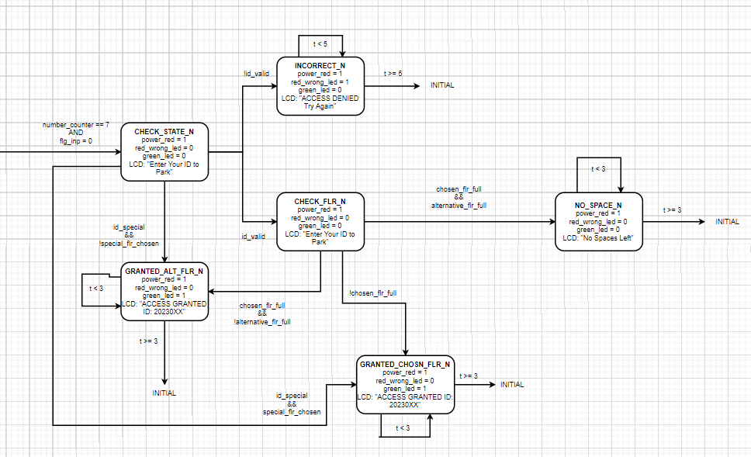

Figure 3 shows the normal FSM in the state diagram.

When we first input the ID, we will check, hence go to the CHECK_STATE_N. If the ID is not valid, meaning the ID given is already in the parking lot or not pre-saved, we will go to the INCORRECT_N where the message “Access Denied” will be displayed and we will stay in this state as long as t<5, once t>=5 we go back to the Initial state. If the ID given is a special one, no need to check for the floor chosen as its value will be overridden since according to the give, the special ID always goes to level 0. Thus, we go to the GRANTED_ALT_FLR_N. Now if given a normal ID and it is valid, the user must choose the floor that they want to park in. If the floor chosen is not full, then we go to state GRANTED_CHOSN_FLR_N where the user parks on a floor of their choice. Otherwise, we go to the alternative floor granted state. For example, if the user wants to park at level 1 and it is full, the system will route it to level 0 as long as level 0 has more spots. If the chosen floor is full and the alternative floor is full, this will lead to the state NO_SPACE_N where the LCD will display the message “NO Spaces Left” and will last for 3 seconds and will go back to the initial state when 3 seconds pass.

### Administrator Mode:

### 

Figure 4 shows the FSM of the administrator mode.

In this system, the initiation of ADMIN Mode is triggered by the pressing the Ctrl and A keys, and a subsequent repetition of this action returns the system to its initial mode from any stage within the system. Once in ADMIN Mode, the user is prompted to input a 7-digit Admin ID. Upon entering the ID, the system performs a validation check. If the entered ID is found to be incorrect, an error scenario unfolds – a red LED activates, the green LED turns off, and the LCD displays the message "Admin Access Denied" for 5 seconds before returning to the initial state. However, if the ID is valid, the user gains access to an Admin state. In this state, the LCD displays "Administrator Mode" and both a red LED and a green LED blink for two seconds. After this brief period, the admin is presented with two options: entering '1' on the keyboard opens the gate, while entering '2' restricts access to one of the IDs. Upon entering '1', a green LED will turn on, a red LED will turn off, and the LCD will display "Gate is Open" for 3 seconds, after which it will return to the initial state. Alternatively, when entering '2', a green LED will turn on, a red LED will turn off, and the LCD will display "Enter ID to restrict" promoting the admin to enter the ID transitioning to the Inputting state. After inputting the complete ID, the system checks for its existence. If the ID does not exist, a red LED activates, and the LCD displays "Invalid ID to Restrict" for 5 seconds before returning to the initial state. On the other hand, if the entered ID exists, a green LED turn on for 3 seconds, indicating a successful restriction. The LCD concurrently displays "ID: 20230XX is RESTRICTED," where XX represents the last two digits of the restricted ID. However, if the ID is already restricted, it will be unrestricted, and the LCD will show "ID: 20230XX is UNRESTRICTED." In both scenarios, the system concludes by returning to the initial state.

# Conclusion

In conclusion, the Parking Management System shows a thorough modernization strategy for parking facilities that takes operational effectiveness and security issues into account. A 7-segment LCD, a PS2 keyboard, LEDs, and an LCD are all integrated to enable easy user interaction and real-time monitoring. The system's flexibility in handling various parking situations is demonstrated by its capacity to control reserved spaces, prohibit unauthorized entry, and grant admin rights to security guards. The experiment also highlights how crucial precise ID management is to maintaining smooth parking operations and avoiding ID duplication or misuse. A strong solution for improving the operation and security of multi-level parking lots is provided by the Parking Management System, which has a timeout mechanism that improves user experience and a clear visual interface made of LEDs and displays. This report lays the groundwork for future developments in intelligent parking solutions by providing a thorough overview of the system's capabilities, design, and implementation.